**Aim:**

The aim of this LMS Lab is to install hadoop in windows 10.

1. **Install Java 7: Download Java 7 :**

***Set environmental variables:***

*System variable:*

Variable: JAVA_HOME

Value: C:\Program~1\Java\jdk1.7.0_79

**Download Hadoop-2.5.x:**

a. Put extracted Hadoop-2.5.x files into E drive. Note that do not put these extracted files into C drive, where you installed your Windows.

b. Create a “hadoop2data” folder inside Hadoop-2.5.x.

c. Go to Hadoop-2.5.x and etc/hadoop and edit followinf files with env.cmd files:

i. core-site.xml

ii. hdfs-site.xml

iii. mapred.xml

iv. yarn.xml

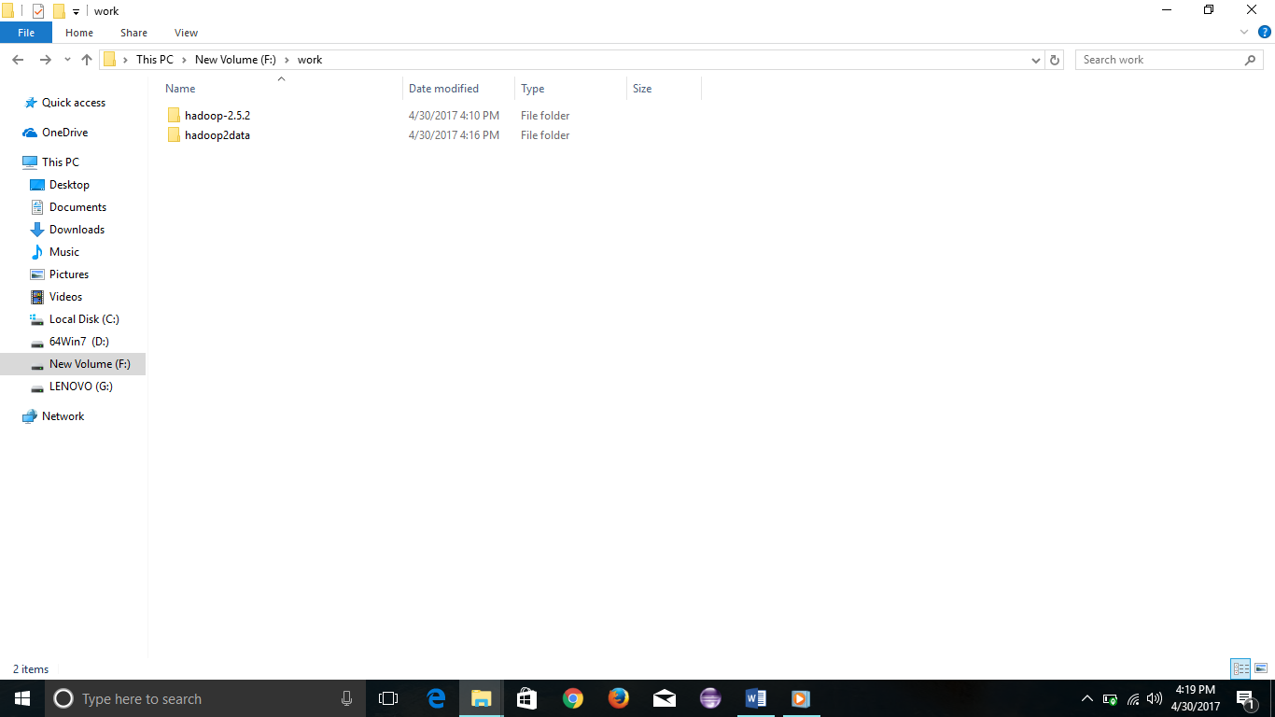

**core-site.xml:**

<?xml version="1.0" encoding="UTF-8"?>

<?xml-stylesheet type="text/xsl" href="configuration.xsl"?>

<configuration>

<property>

<name>fs.defaultFS</name>

<value>hdfs://localhost:8020</value>

</property>

</configuration>

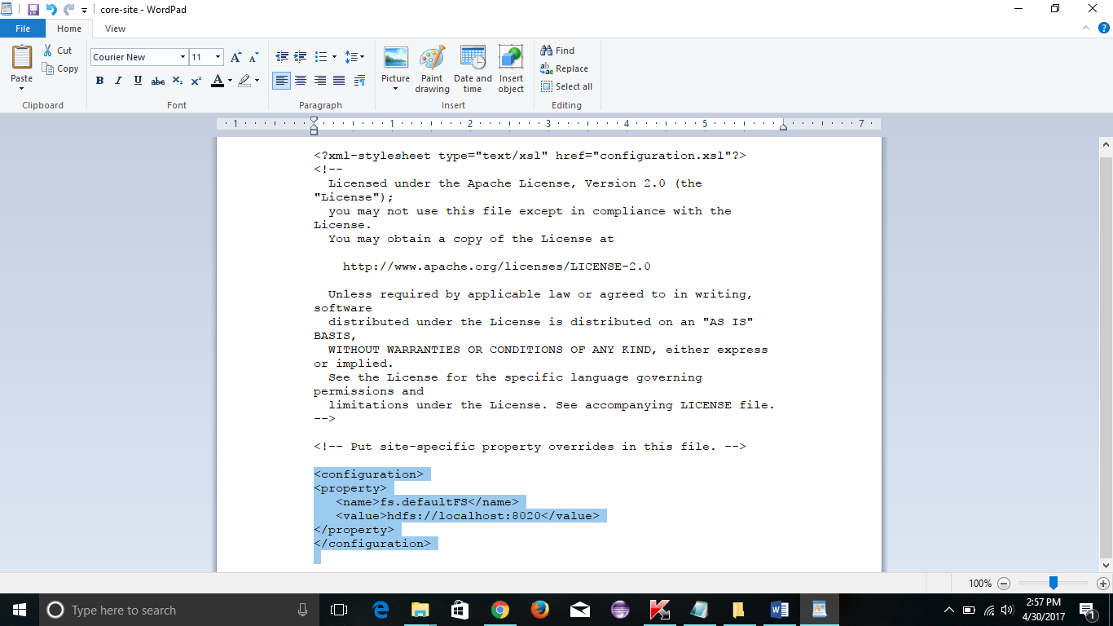

**hdfs-site.xml:**

<?xml version="1.0" encoding="UTF-8"?>

<?xml-stylesheet type="text/xsl" href="configuration.xsl"?>

<configuration>

<property>

<name>dfs.replication</name>

<value>1</value>

</property>

<property>

<name>dfs.namenode.name.dir</name>

<value>F:\work\hadoop2data\dfs\name</value>

</property>

<property>

<name>dfs.datanode.data.dir</name>

<value>F:\work\hadoop2data\dfs\data</value>

</property>

<property>

<name>dfs.namenode.checkpoint.dir</name>

<value>file:\work\hadoop2data\dfs\namesecondary</value>

</property>

</configuration>

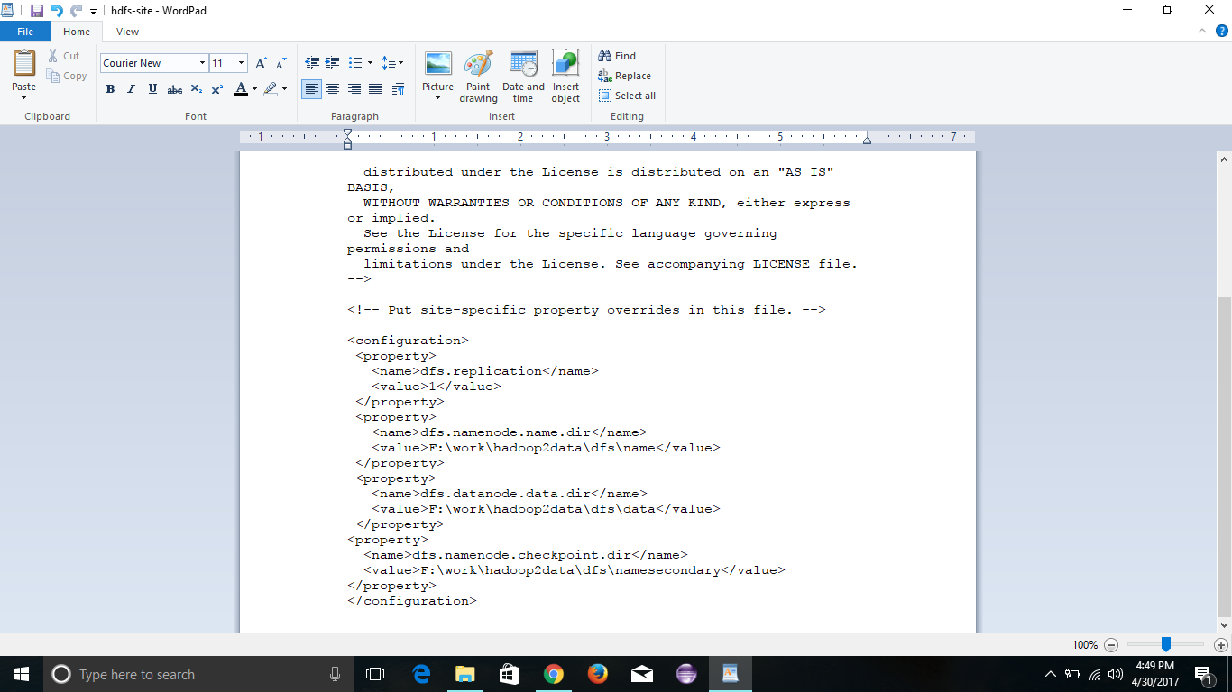

**hadoop-env.cmd:**

set JAVA_HOME=C:\Progra~1\Java\jdk1.7.0_79

set JAVA_HOME=%JAVA_HOME%

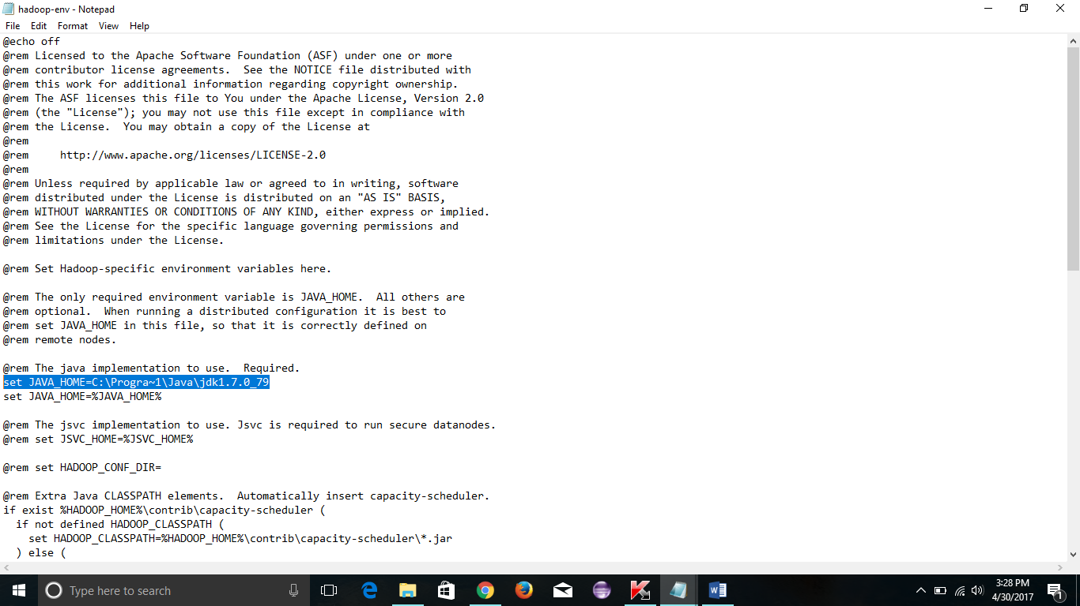

**mapred-env.cmd:**

set JAVA_HOME=C:\Progra~1\Java\jdk1.7.0_79

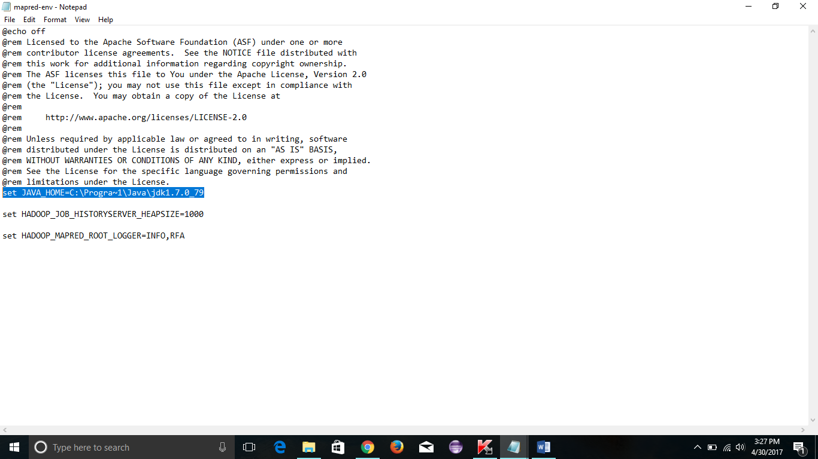

**mapred-site.xml:**

<?xml version="1.0"?>

<?xml-stylesheet type="text/xsl" href="configuration.xsl"?>

<configuration>

<property>

<name>mapreduce.framework.name</name>

<value>yarn</value>

</property>

</configuration>

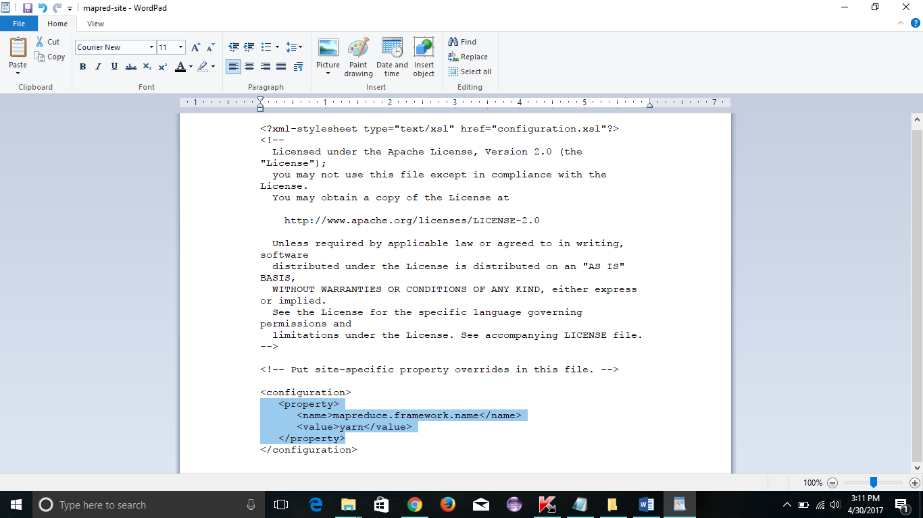

**yarn-site.xml:**

<?xml version="1.0"?>

<?xml-stylesheet type="text/xsl" href="configuration.xsl"?>

<configuration>

<property>

<name>yarn.resourcemanager.hostname</name>

<value>localhost</value>

</property>

<property>

<name>yarn.nodemanager.aux-services</name>

<value>mapreduce_shuffle</value>

</property>

<property>

<name>yarn.nodemanager.aux-services.mapreduce_shuffle.class</name>

<value>org.apache.hadoop.mapred.ShuffleHandler</value>

</property>

</configuration>

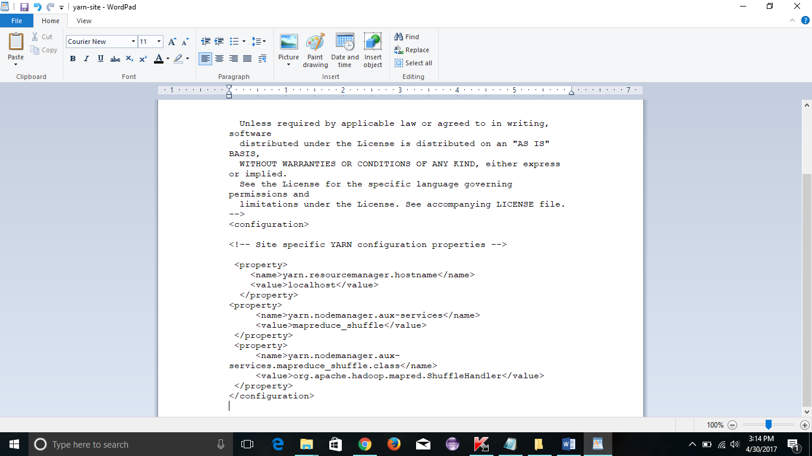

**yarn-env.cmd:**

set JAVA_HOME=C:\Progra~1\Java\jdk1.7.0_79

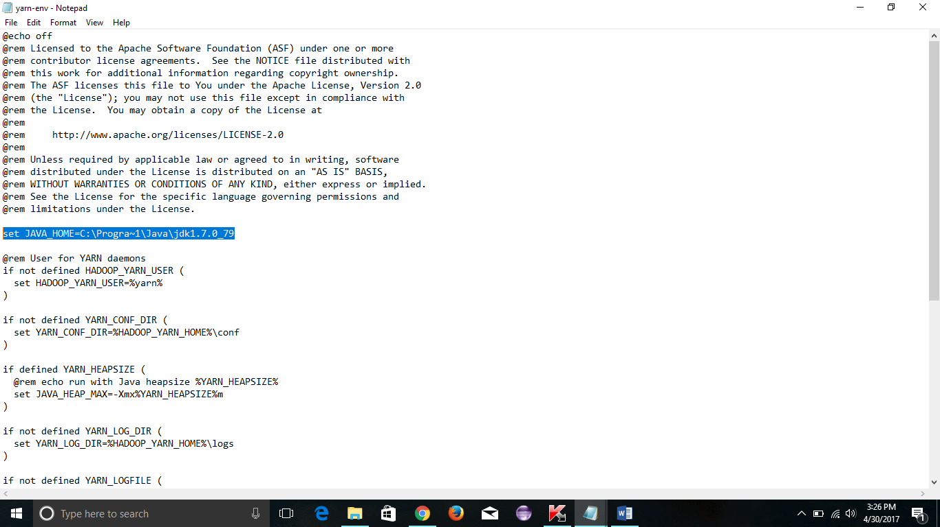

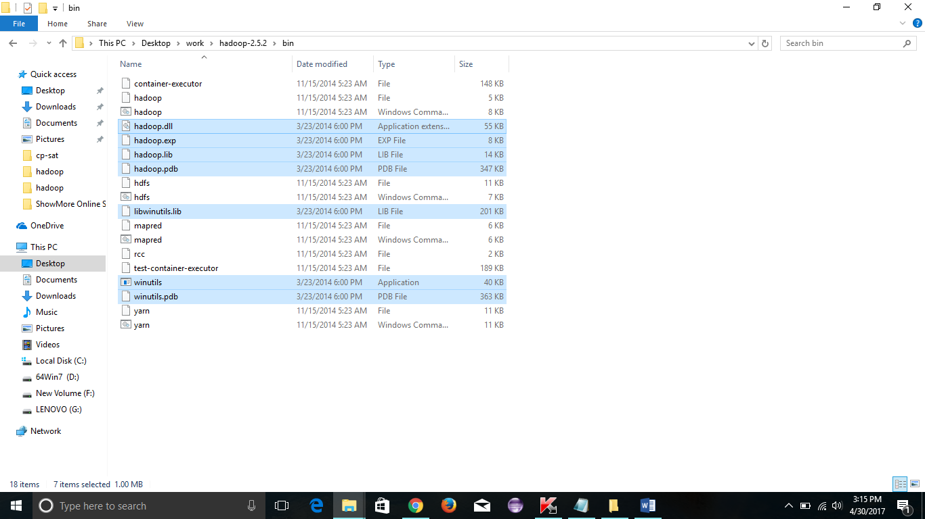

**Setting path locally as below.**

set HADOOP_HOME=F:\work\hadoop-2.5.2

set PATH=%JAVA_HOME%\bin;%HADOOP_HOME%\bin;%HADOOP_HOME%\sbin;%PATH%;

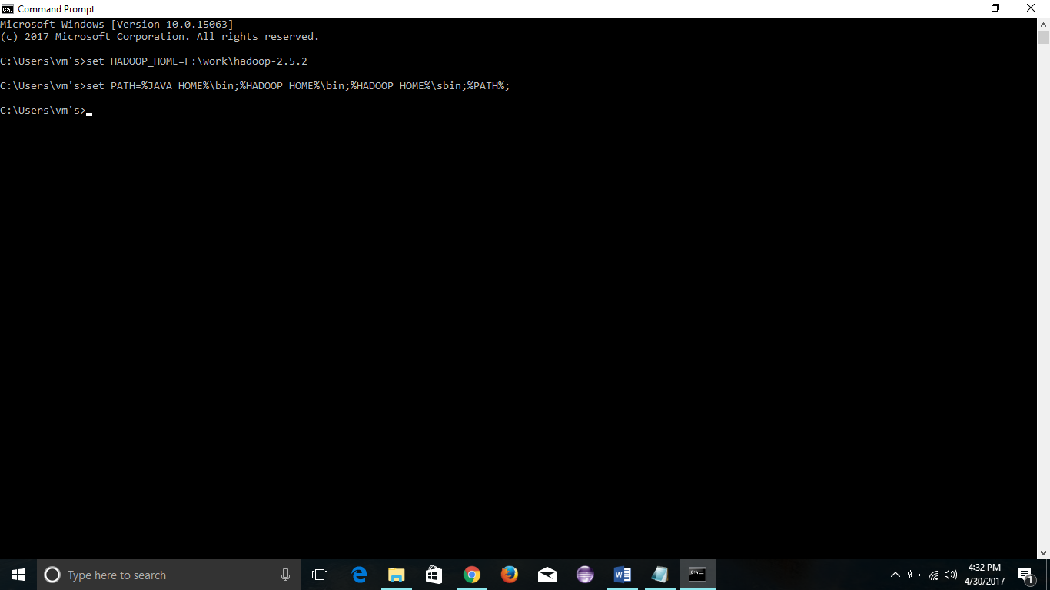

**Formating the namenode as below command**

**Command:**

hadoop namenode -format

or

hdfs namenode -format

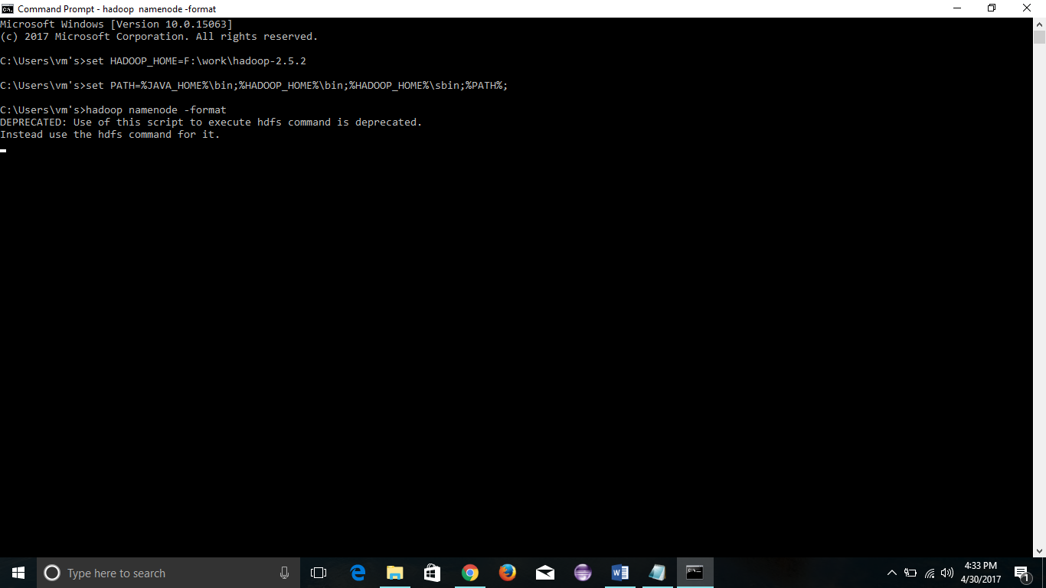

To start hadoop.

**Command:**

start-all

To Stop Hadoop

stop-all

